***PRACTICE PREDICTIONS OF RENEWABLE GENERATION AND LOAD BY USING VARIOUS DEEP LEARNING ALGORITHMS***



**Proposal for Project**

**Al-Khawarizmi Institute of Computer Science**

**University of Engineering & Technology Lahore**

**Muhammad Amir**

**E-mail:amirshahzad0650@gmail.com**

Contents

1. Introduction 3

2. Literature Review 3

5. Aim and Objectives 3

7. References 3

*Abstract*

Analysis of energy forecasting is becoming increasingly important these days, especially with increasing usage & integrating of renewable energy resources & external energy plants. Forecasting for power is an important part of preparation a power consumption, control, & service plan. In addition, forecasting means trying to predict the amount of power/energy required to meet the needed power or capacity to deliver a given load. In this report, we will look at how we use long-term memory, or LSTM, to predict and predict load production data. In the realm of deep learning, it is a repetitive form of neural network construction. LSTM has feedback links, unlike standard feedforward neural networks. It can process not only data points, but also whole data sequences. Our aim is to assist in clearing up the problem of forecasting of power supply by providing short descriptions of the proposed system. Using this process, this report predicts production data, solar load, and temperature. Modeling, predicting, and predicting were our goals. It also includes drawing diagrams. For this reason, the analysis provides a good understanding of predicting energy burden in future research and studies.

1. *Introduction*

Electrical load is the amount of energy that should be delivered to customers. Electrical capacity varies, and it is not always possible to properly and efficiently store built-in electricity. It assists power stations in making critical decisions, reducing energy production costs and improving accuracy. The most important method of predicting short-term energy load, used to plan energy flow for users. Short, medium- and long-term forecasts are made ahead of time. To produce good quality energy, energy systems require robust control functions that can quickly adjust energy quality parameters [EN 50160]. The power load forecasted in this short-term has a very

Major role in electric utility. The reason to this study is, due to increasing and non-stop use of renewable energy resources, which are clean & free energy resources, forecasting models are being established around the world to integrate renewable energy sources as much as possible into supply demand. Since it is not possible to store electricity generated, the most important challenge in predicting electricity consumption is to build a reliable and accurate model for balancing energy demand. The energy produced must be loaded in the most efficient way to keep the power grid balanced. This concept aims to be a critique of previous research-based research. This study will serve as an analysis of previous studies that focused on the development of predictable models that require energy for this purpose. This study will support researchers and students by providing a brief overview of power forecasting. Electricity is generated from renewable energy sources under unpredictable weather conditions. Research to predict the burden, suggested many methods. Short-term forecasts range from 1 hr. to 7 days, intermediate predictions from quarter of the month to a year, and long-term forecasts from year to year. Direct balances lead to adequate investment in operating and maintenance costs, consistent efficiency of power supply and delivery system, and appropriate future options. Excessive estimation of the effects of anticipation of the load is an unnecessary increase in capturing and operating costs. Then came methods like Linear Regression, which we used for a long time because of their accuracy and simplicity, but when it comes to long-term forecasts, ANN showed great interest and took the reins. Not only were that, but techniques such as Expert System, Fuzzy Logic, and Support Vector Machine used.

Because of their offline map prediction and standard performance, neural networks are ready to predict load. Weather data, pre-day weather forecast capabilities, and day type are used as variables to include most of these network-based methods recorded to date. As a result, predicting future load on special weekends and days is difficult, as is the case with neural networks.

This work involves the design of in traditional methods, neural networks use all the related daily information to learn the pattern of similarity. However, reading all the details of the day related to the hard work you do not devote to learning from the neural network. As a result, neural network formation and improving through learning time should be reduced.

LSTM module has three gates and a cell shape, allowing you to choose whether to read, not read, or store information from each device. With only a few interactions, the state of the cell in LSTM helps data flow through units without modification. Each unit has an input, output, and forgetting gateway that adds or removes data in a cell state. Forget Gateway uses the sigmoid feature to check which information from the previous cell is to be forgotten.

The input gate uses the replication function that directs the point of 'sigmoid' and 'tanh' to monitor the flow of information in the current state of the cell.

1. *Long Short-Term Memory Network:*

Short-term long-term memory networks and recurrent neural networks can learn order dependence on sequential prediction problems. LSTM for in-depth learning is a complex subject. In this article, you will learn about LSTMs from the names of researchers who have developed approaches to applying new and stressful problems.

1 input layer, 1 hidden layer, and 1 extraction layer used in our networks ... Memory cells and gate units are located in a private (fully connected) layer. Within the CEC of each memory cell, two gate units learn to turn on and off access error ow. Similarly, a recurring output gateway prevents other units from being disturbed by the memory content that is actually inactive.

The LSTM layer is made up of memory blocks, which are always connected blocks. These blocks can be considered as separate form of digital memory computers. Each of them has one or more frequently joined memory cells and 3 repetition unitse-einput gates, output, and memory - providing continuous similarity of writing, reading, and resetting input, output, and forgetting gateways.

The idea is to use one LSTM to learn the input sequence, one step at a time, to get a large vertical presentation vector, and then use another LSTM to output the output sequence for that vector. LSTM's ability to successfully read data with long-term dependency makes it a natural choice for this application due to the time remaining between the entries and their corresponding results. In doing so, we have introduced many temporary dependencies that have made the problem of simplification much easier. … A simple strategy to change the words in the basic sentence is one of the most important technical contributions to this project.

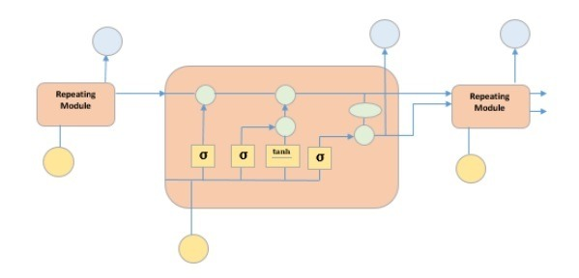

Fig 1: Basic LSTM Architecture

Long-Term Memory Networks (LSTMs) are an RNN method that can learn long-term dependencies. Hochreiter & Schmidhuber (1997) appreciated it, and many people refined it and made it attractive in the next work. They are now widely used and are very effective in a variety of problems.

LSTMs are specially designed to prevent long-term reliability. They do not have to work hard to remember details long; it is second nature to them! Both recurrent neural networks are made up of a set of recurrent neural network modules.

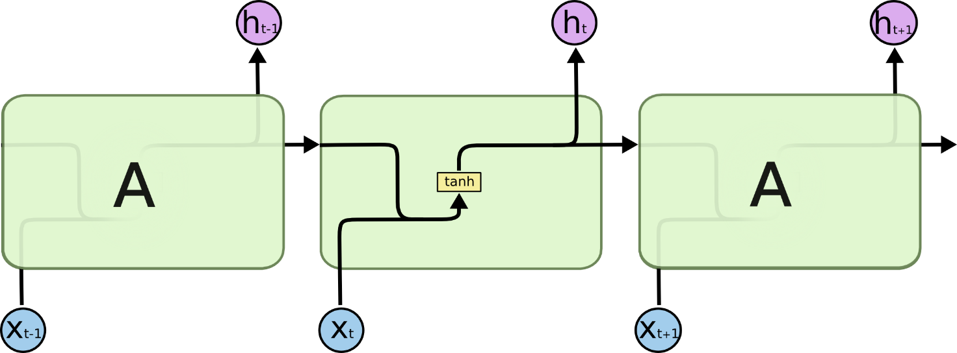

Fig 2: Repeating module in a standard RNN contains a single layer

LSTMs have a chain-like structure too, but a repetitive module is different. Instead of a single neural network cover, there are four, each of them interacting in a certain way.

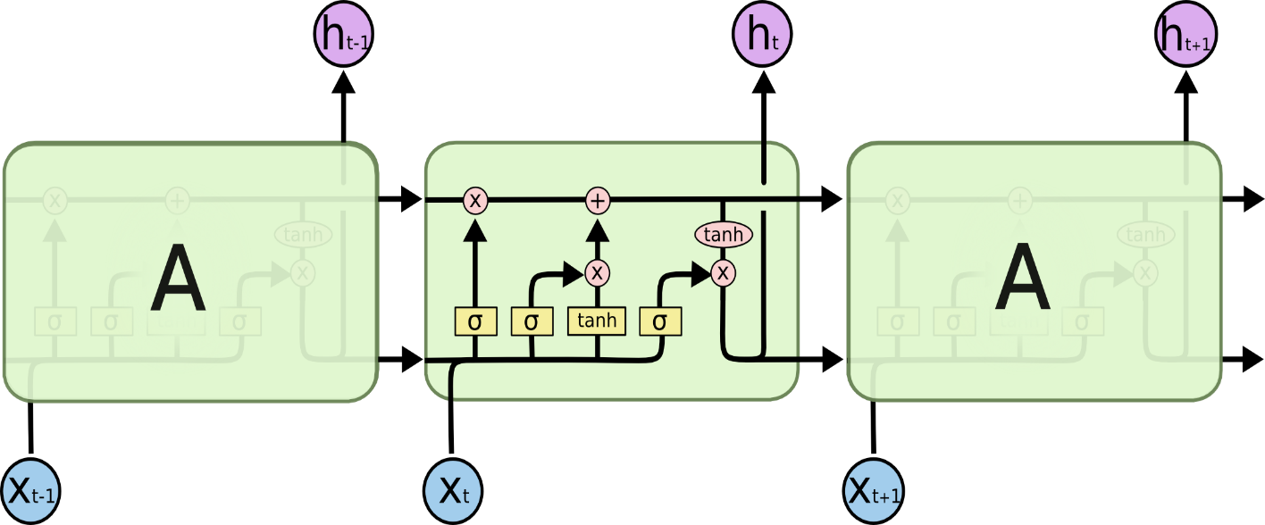

Fig 3: Repeating module in an LSTM contains four interacting layers

The shape of the cell, the horizontal line running across the diagram, is the key to LSTM. The shape of the cell is similar to that of a moving belt. With a few simple connections, it runs directly into the entire series. It's quite simple that the data just flows unchanged. LSTM can remove or add information to a cell, which is carefully controlled by portable components.

The first step in our LSTM is to find out which information from the cell will be discarded. The layer of «forget the gate, » the sigmoid layer, makes this decision. It checks h and x and returns the value between 0 and 1 in each number in the cell C.

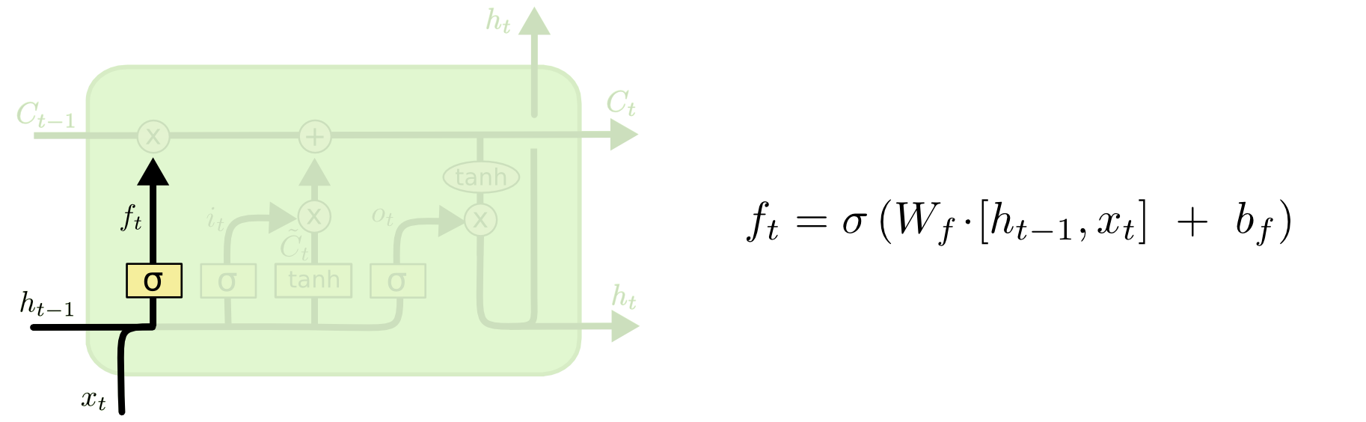

The next step is to determine what new information we will store in the cell. First, the sigmoid layer called the «input gate layer» determines what values ​​we will review. In the next step, we will bring the two together to create a review for the government.

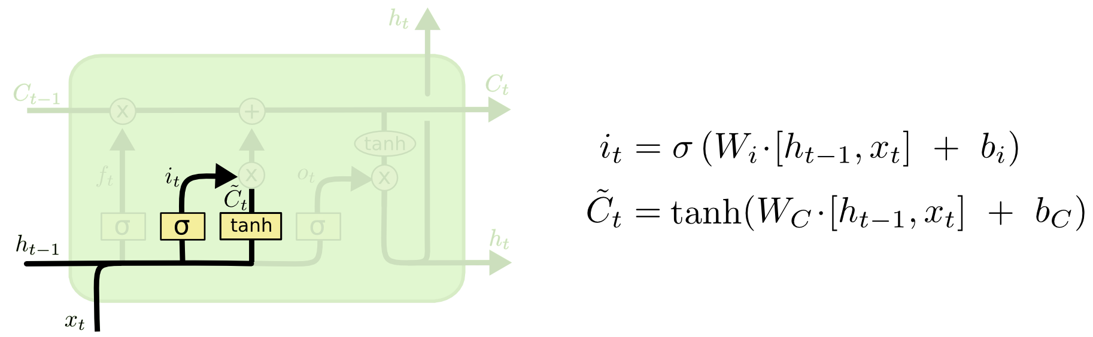

Time to switch from old Ct1 cell to new Ct cell. Extend the previous situation by ft, ignoring the things we chose to forget earlier. This is the current set of candidate values, measured by how often each province's value has been changed.

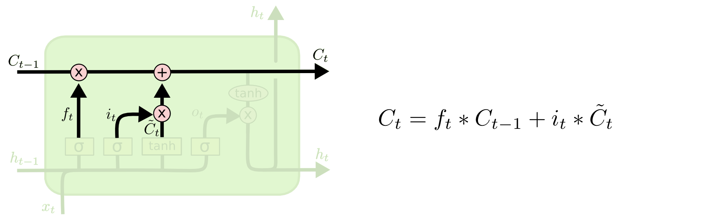

This function will depend on the condition of our cells, but will be filtered. First, we use a sigmoid layer to determine which features of the cell structure will be released. The state of the cell is transferred to tanh and is repeated with the removal of the sigmoid gate, which has only led to the stages we want to remove.

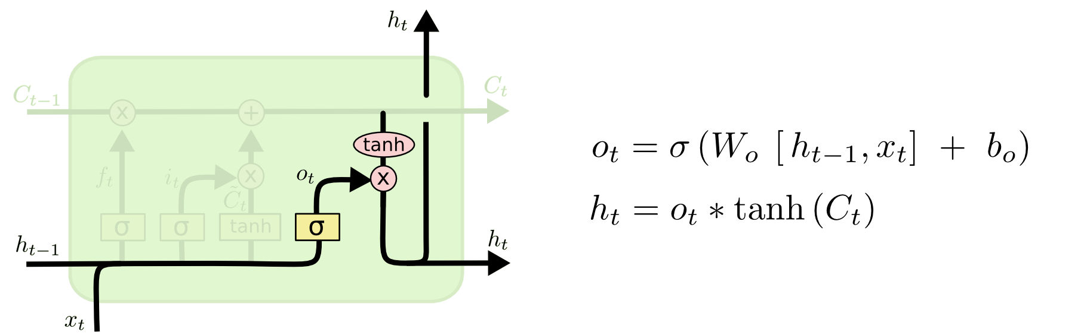

So far, I have mentioned standard LSTM. However, not all LSTMs are made equal. Almost all papers including LSTM tend to use a slightly different system. Although the difference is small, it is worth noting.

Gers & Schmidhuber (2000) introduced "peephole communication" as a common variant of LSTM.

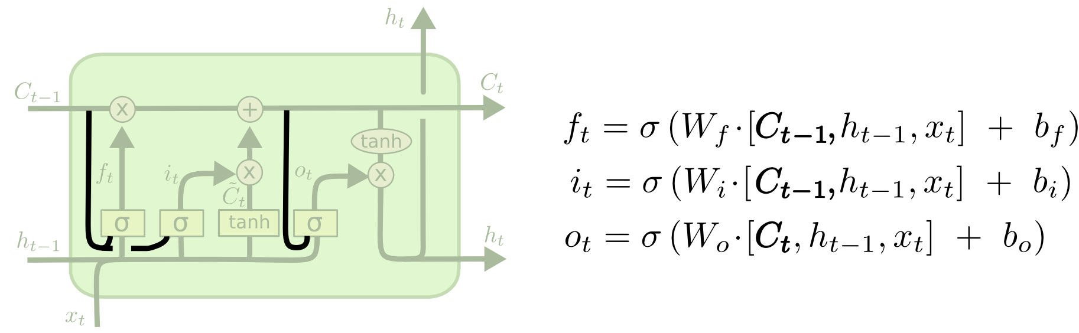

Peepholes are used on all gates in the drawing above, but several sheets will provide some holes but not others. We make these decisions together rather than deciding individually what to leave out and what new information to apply.

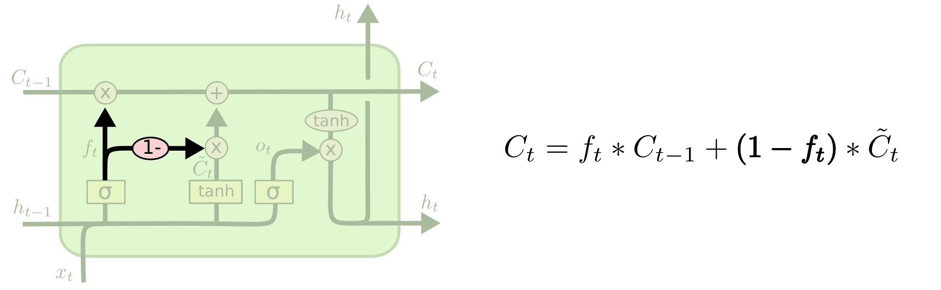

The emerging model is easier to understand than the traditional LSTM models, and is gaining popularity. These are just a few of the many well-known features of LSTM. Make good comparisons of standard models, and you will see that they are all the same.

Earlier, I mentioned the amazing results that people get through RNNs. Basically, all of this is available using LSTMs. Hopefully, their step-by-step approach to this article has made them more approachable.

LSTMs have been a major step forward in achieving RNNs. It is natural to ask: is there another big step? A common view among researchers is: «Yes! There is next step and attention! »The idea is to allow all RNN measures to select the data to be viewed from a specific database. In fact, Xu, et al. do it right - it can be a fun first place if you want to check attention! There have been many exciting results using attention, and it looks like there is more to come…

1. *Implementation of LSTM model and load prediction in Python 3*

According to the two-year load data sampled with every hourly peak load from 1st Nov 2003 to 31st October 2005. The solar and temperature data were also being provided for said period of time. This meant that there were three datasets which were being provided as input.

These datasets included 17445 data points out of which 15000 points were set aside for model training and 1000 points were for validation of the data. Remaining 1445 were being used for testing. After that, modelling, forecasting, predicting and result plotting were being followed.

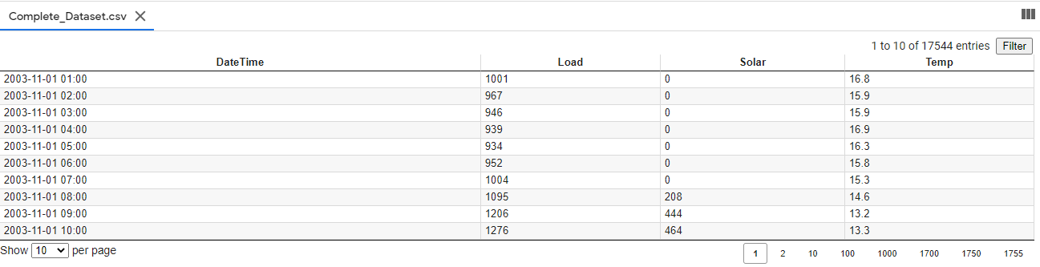

*Fig 4. Complete Dataset*

The three datasets which were being provided did not contain data and time so for using the LSTM model we generated date and time on the given datasets. After this we displayed this time and date in an index and then we converted all these datasets into a single data frame. We needed to do preprocessing of the dataset. Hence the reason for the single data frame. Then we efficiently applied the LSTM model. A single file of dataset was completed in CSV format.

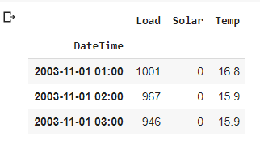

*Fig 5. Read Dataset*

Different libraries in the software were being imported for different tasks. These libraries included; Pandas; Numpy; Matplotlib; seaborn; pprint; datetime; keras. Models.

The plot for the predicted data is given in figure 6.

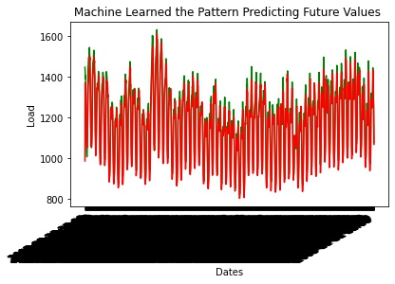

*Fig 6. Output Load forecasting*

The following test data as shown in figure 7 was being used for load prediction.

This test data includes for load, solar and temperature data.

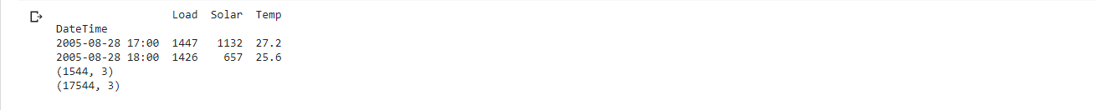

*Fig 7. Test Data*

Out train and test datasheet shape were as shown in the figures below:





We trained our model on the basis of LSTM method and the following is the sample of our result during LSTM model training.

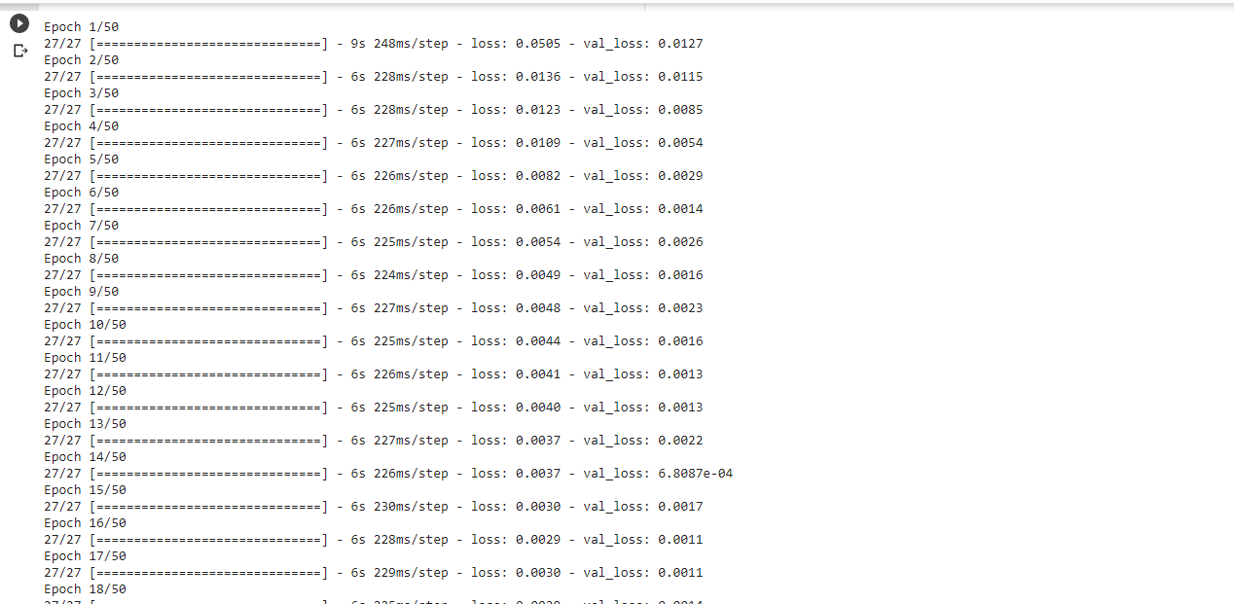

*Fig 8. Sample Data of LSTM model training*

Apart from the plot graphing for output load forecasting, the data is also being displayed in the figure below,

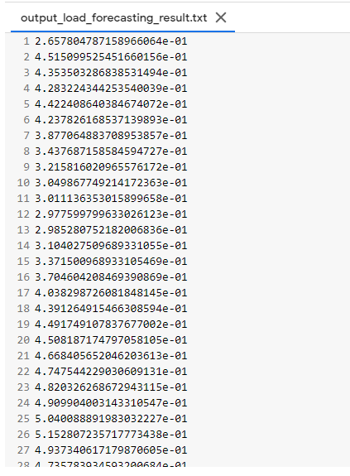

Reversal is a term used to describe the relationship between output and objectives measured in R values. Intimate relationships have a value of R 1, and a random relationship has a value of R of 0. The average square difference between output and objectives is known as Mean squared error. The lower the price, the better. There is no error if the value is zero.

The statistical indicator of how reliable the weather system is a mean percentage error (MAPE). It is measured as the absolute percentage error in each time measure minus the actual values ​​divided by real values ​​and expressed as a percentage. Where the real value and Ft value are predicted, Et is the error value, equal to At-Ft, as follows:

𝑛

𝑀𝐴𝑃𝐸 = 1/𝑛 ∑ |𝐸𝑡/𝐴𝑡|

𝑡=1

The value for MAPE after running the training was

MAPE: 1.903445356004548

The values obtained for MAE, MSE, RMSE, True load and predicted load are given below in the figure.

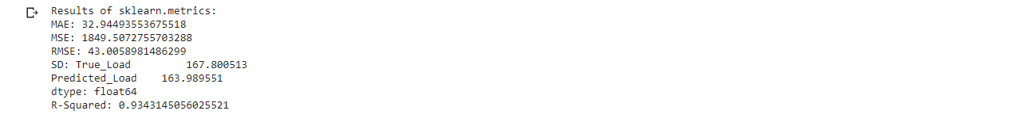

Below is the data table for predicted load and total load from which we can see that our model is being improved with the passage of time.

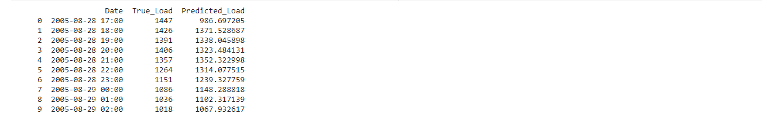

The value of R for our prediction was 0.96*.*

1. *Conclusion*

Python 3 is used to build a load prediction model Network design, Neural Network training, and simulation of test results have all been successfully completed with a high level of accuracy, resulting in a 24-hour load exit. After training the network with upload information obtained from assignment data, a set of adjusted weights and related discrimination was found. The accuracy of the forecast is verified by comparing the results generated by the network with the results obtained from the data for the next year. Prior to reaching the excellent 0.9, MAE 32.95 MA, and 1849.5 MSE, many network structures were trained and replicated. If more factors are added as input such as temperature, Humidity, wind, holidays and other environmental factors than the predication can be better by training the neural network.

1. *References* 
   1. Shichao Liu1,2, Peter Xiaoping Liu1,2 , Xiaoyu Wang3,4, Zhijun Wang3 , Wenchao Meng3 Effects of correlated photovoltaic power and load uncertainties on grid-connected microgrid day-ahead scheduling
   2. One-Hour-Ahead Load Forecasting Using Neural Network Tomonobu Senjyu, Member,

IEEE, Hitoshi Takara, Katsumi Uezato, and Toshihisa Funabashi, Senior Member, IEEE

* 1. Electric Load Forecasting Using An Artificial Neural Network D.C. Park, M.A. El-Sharkawi,

R.J. Marks 11, L.E. Atlas and M.J. Damborg

* 1. A Deep Neural Network Model for Short-Term Load Forecast Based on Long Short-Term Memory Network and Convolutional Neural Network Chujie Tian 1,, Jian Ma 1 , Chunhong Zhang 2 and Panpan Zhan 3
  2. Short-Term Load Forecasting Using Artificial Neural Network Muhammad Buhari, Member, IAENG and Sanusi Sani Adamu